What is the cost of living crisis and what does it mean?
The ‘cost of living crisis’ refers to the fall in ‘real’ incomes (that is, adjusted for inflation and tax) that the UK has experienced since late 2021. It is being caused by a combination of high inflation outstripping wage increases and upcoming tax increases that have squeezed incomes for many households.
The Chancellor’s Spring Statement on 23 March 2022, confirmed that consumers should be braced for things getting more expensive at a faster rate later in the year. He announced he would cut fuel duty, raise the threshold at which people start paying National Insurance, and pledged to cut the basic rate of income tax before the next general election.
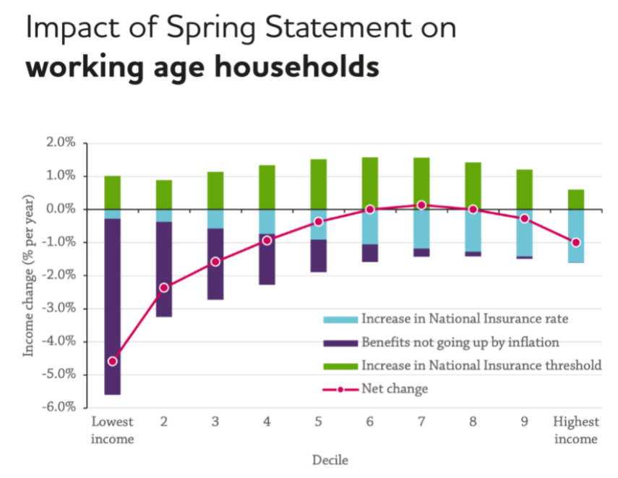
Commenting on the statement Dave Innes, Head of Economics at the Joseph Rowntree Foundation, said: “Security is only real if it’s for everyone - the choices the Chancellor has made won’t deliver any security for those at the sharpest end of this crisis, instead he has abandoned many to the threat of destitution. The Chancellor has acted recklessly in pressing ahead with a second real-terms cut to benefits in six months, while prioritising people on middle and higher incomes.”
They have analysed the impact of the Chancellor's failure to increase benefits in line with current inflation levels, along with the 1.25% increase in National Insurance and change to the earnings threshold at which it is paid.
As a result they believe that around 600,000 people will be pulled into poverty, of which around a quarter are children and that families in poverty will be £446 per year worse off in 2022-23 compared to if benefits had been uprated in line with current inflation levels. Households in poverty who are not in work – those who are either job seeking or unable to work due to ill health, disability or caring responsibilities – are particularly harshly affected by the changes.
The Resolution Foundation have sited that “the typical working-age household faces an income fall of 4%, or £1,100, in 2022-23. But the greatest falls will be felt by the poorest quarter of households who are set to see their incomes fall by 6 %. This will see a further 1.3 million people fall into absolute poverty next year, including 500,000 children – the first time Britain has seen such a rise in poverty outside of recessions.”
According to YouGov just 5% of Britons describe themselves as being ‘very comfortable’ financially while 14% are struggling to make ends meet and 3% say they cannon afford their costs at all and are having to go without essentials. While 15% of financially-comfortable Britons say the price of groceries has seen a ‘major’ increase in the last few months, this rises to a third (36%) of those who say they can only just afford costs or cannot make ends meet at all. Similarly, a quarter (24%) of Britons who are ‘very’ or ‘relatively’ comfortable say they have seen a ‘minor’ increase in the price of groceries, compared to just 16% of those struggling financially.
The Living Wage Foundation (the organisation behind the London Living Wage) have stated that the cost of living crisis and low paid work will disproportionately affect women. Their research shows that a fifth of women in work (20.4%) are paid below the real Living Wage, approximately 2.9m people, compared to 14% of men (1.9 million). As a result, jobs held by women account for almost 60% (59.7%) of all jobs paid below the Living Wage. They have coined the phrase “she-flation” as research has shown that women are more significantly impacted by inflation due to their prevalence in low paid roles and spending commitments. Women more commonly spend more of their income on non-durable household goods, for example food and cleaning products, which are typically more susceptible to inflation-induced volatility.
What does this mean for London and Londoners?

The Mayor of London, Sadiq Khan, stated that the cost of living crisis has shown nearly 80% of Londoners have increased costs in the last six months and 13% are going without essentials or relying on credit. In response to the spring statement he stated “Londoners are facing a triple whammy of energy price hikes, tax increases and rising inflation – and this spring statement failed to ease this cost of living crisis.”

The cost of living was already a challenge for Londoners before the pandemic, with median weekly earnings for employees in London were below pre-2008 levels when adjusted for inflation. Our member London Councils shared polling in late 2021 showing that the cost of living was the most important issue facing Londoners. And with London being home to 5 of the 25 most deprived council areas in England and 27% of Londoners living in poverty after housing costs are factored in, Londoners are set to face a real hit with the cost of living crisis. Poverty rates among families with children in London have consistently been the highest of any region, with nearly 4 in 10 children in poverty.

What’s needed to support Londoners through the crisis and beyond?

Although lots of people will need help in the immediate term, there also needs to be long term change to ensure the living standards of Londoners are improved.

Our members Peabody launched their annual Peabody Index earlier this month which reveals “the disproportionate impact the cost-of-living crisis is having on those with low incomes. The economy is picking up, but barriers to employment and in-work poverty persist for many.” Their recommendations for improving the lives of those on low wages are to:
- Ensure the Levelling Up agenda has a stronger local focus, giving greater say to local authorities and mayors.
- Extend the Lifetime Skills Guarantee for those with Level 3 qualifications who are earning below national minimum wage, to include Londoners earning below the London Living Wage.
- Improve support via the benefits system to ensure it keeps pace with the rising costs of living.
- Provide further support to combat fuel poverty. We call for an extension of the Warm Homes Scheme to give a one-off grant to all households receiving means-tested benefits.
Our members Trust for London, have been funding the Living Wage Foundation “to persuade other employers that paying a living wage is the right thing to do in order to help lift the working poor of London out of poverty.” Another initiative working for longer term change is Debt Free London, a partnership of 26 charities led by our member Toynbee Hall.

We look forward to hearing further knowledge and intelligence from members during our March insight meeting, after which we’ll update this briefing with further information about what funders are doing in response to the crisis.

Further reading:

Living Standards Outlook, Resolution Foundation - https://www.resolutionfoundation.org/publications/the-living-standards-outlook-2022/

Peabody Index, Peabody – https://www.peabody.org.uk/about-us/what-we-do/research/peabody-indexes

The Road Ahead, NCVO - https://blogs.ncvo.org.uk/2022/01/18/the-road-ahead-2022-finding-a-new-practicality-through-uncertain-times/

Charity Landscape Report - https://www.cafonline.org/about-us/publications/charity-landscape-2022

Living Wage Foundation - https://www.livingwage.org.uk/

GLA Recovery Forum, GLA - https://www.london.gov.uk/coronavirus/londons-recovery-coronavirus-crisis/london-recovery-board

https://www.instituteforgovernment.org.uk/explainers/cost-living-crisis
https://www.bbc.co.uk/news/business-60819205
https://www.jrf.org.uk/press/chancellor-has-abandoned-many-threat-destitution-not-economic-security-jrf-responds-spring
https://www.jrf.org.uk/press/600000-will-be-pulled-poverty-result-chancellors-inaction
https://www.resolutionfoundation.org/publications/inflation-nation/
https://yougov.co.uk/topics/politics/articles-reports/2022/02/04/cost-living-crisis-four-ten-britons-expect-their-h
https://www.livingwage.org.uk/news/cost-living-crisis-affecting-women
https://twitter.com/MayorofLondon/status/1489923859969044486?ref_src=twsrc%5Etfw%7Ctwcamp%5Etweetembed%7Ctwterm%5E1489923859969044486%7Ctwgr%5E%7Ctwcon%5Es1_&ref_url=https%3A%2F%2Fwww.cityam.com%2Fkhan-urges-government-to-get-a-grip-on-cost-of-living-crisis%2F
https://www.londonworld.com/news/politics/spring-statement-london-mps-react-to-rishi-sunaks-fuel-duty-cut-and-national-insurance-hike-3623805
https://data.london.gov.uk/economic-fairness/living-standards/
https://beta.londoncouncils.gov.uk/news/2021/londoners-feel-cost-living-squeeze
https://www.peabody.org.uk/about-us/what-we-do/research/peabody-indexes/index-11
https://www.livingwage.org.uk/principal-partners

